**Barn Hunt Trial MRV and Time Calculations Sheet**

[https://docs.google.com/spreadsheets/d/1w3f2ECtHX4YFaPOgts_XYY4zo8mVXLNGZCPIAVFtFPc/copy](https://docs.google.com/spreadsheets/d/1w3f2ECtHX4YFaPOgts_XYY4zo8mVXLNGZCPIAVFtFPc/edit?usp=sharing)

This will give you a forced copy so you can tweak it to your preferences.

This sheet calculates the estimated length of a trial and the MRV to help trial organizers ensure that the trial adheres to BH judging and trial length limits. It also allows clubs that want to load balance the rings to see what classes can be moved.

The top section calculates the estimated trial length.

| It is designed for 2 rings. The salmon is Ring 1. The blue is Ring 2.  You do not have to use both rings for the sheet to function correctly.  For a multiple-day event, you need to duplicate the sheet for as many days as you want. |  |
| --- | --- |
| All Ring 1 data is entered into Columns E and H (seen in red)  All Ring 2 data is entered in Columns P and U  The formulas are set to calculate using the judge efficiency times:  I- 2 minutes  N- 3 minutes  O- 3.5 minutes  CZ8- 5 minutes  S- 5 minutes  M- 6 minutes |  |
| There is time built in for builds/briefs/getting the blind. This can be adjusted as needed This is in the white cells.  It is currently set to 5 min between Instinct and Novice and 10 minutes for the other classes. There is also a 30-minute lunch added on one build time to allocate for a lunch break. It can also be removed if you use a ROJ and don’t stop the ring for lunch.  If you are only doing one ring, you will want to set the build times to 0 for Ring 2 and ensure no runs are recorded in that section.  If you are running two rings, you will want to remove the build times allocated for the classes that that ring will not use. |  |
| The summary totals each trial's length and number of runs, as well as the overall total for the ring each day.  The cells are conditionally formatted to turn red if the value exceeds 9 hours. |  |

**MRV Calculations**

The bottom is the MRV calculation section

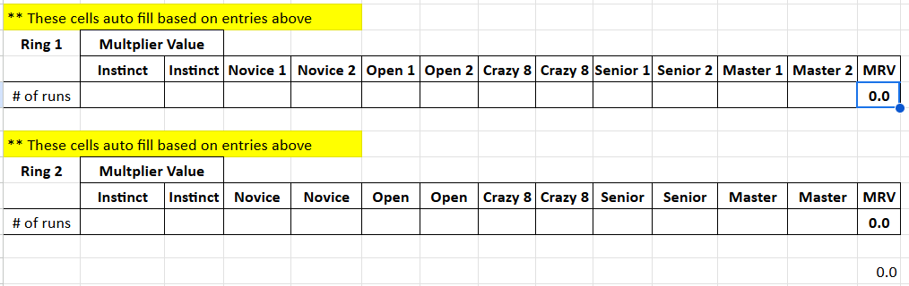

It automatically fills it out based on the entry numbers above. It calculates each ring as well as the day. The cells are conditionally formatted to turn red if the value exceeds 260. The formula uses the MRV from the rulebook:

| I- 1 | N- 1.5 | O- 2 | CZ8- 2.5 | S- 2.5 | M- 3.0 |
| --- | --- | --- | --- | --- | --- |